**BANK LOAN REPORT QUERY DOCUMENT**

1. **BANK LOAN REPORT | SUMMARY**

**KPI’s:**

**Total Loan Applications**

SELECT COUNT(id) AS Total_Loan_Applications FROM bankloan.financial_loan

**MTD Loan Applications**

SELECT COUNT(id) AS MTD_Total_Loan_Applications

FROM bankloan.financial_loan

WHERE MONTH(issue_date) = (SELECT MAX(MONTH(issue_date)) FROM bankloan.financial_loan)

AND YEAR(issue_date) = (SELECT MAX(YEAR(issue_date)) FROM bankloan.financial_loan);



**PMTD Loan Applications**

SELECT COUNT(id) AS PMTD_Total_Loan_Applications

FROM bankloan.financial_loan

WHERE MONTH(issue_date)=(SELECT MAX(MONTH(issue_date)) FROM bankloan.financial_loan)-1

**Total Funded Amount**

SELECT SUM(loan_amount) AS Total_Funded_Amount FROM bankloan.financial_loan;

**MTD Total Funded Amount**

SELECT SUM(loan_amount) AS MTD_Total_Funded_Amount

FROM bankloan.financial_loan

WHERE MONTH(issue_date) = (SELECT MAX(MONTH(issue_date)) FROM bankloan.financial_loan)

AND YEAR(issue_date) = (SELECT MAX(YEAR(issue_date)) FROM bankloan.financial_loan);



**PMTD Total Funded Amount**

SELECT SUM(loan_amount) AS PMTD_Total_Loan_Applications

FROM bankloan.financial_loan

WHERE MONTH(issue_date)=(SELECT MAX(MONTH(issue_date)) FROM bankloan.financial_loan)-1

**Total Amount Received**

SELECT SUM(total_payment) AS Total_Amount_Received FROM bankloan.financial_loan

**MTD Total Amount Received**

SELECT SUM(total_payment) AS MTD_Total_Amount_Received FROM bankloan.financial_loan

WHERE MONTH(issue_date) = (SELECT MAX(MONTH(issue_date)) FROM bankloan.financial_loan)

AND YEAR(issue_date) = (SELECT MAX(YEAR(issue_date)) FROM bankloan.financial_loan);



**PMTD Total Amount Received**

SELECT SUM(total_payment) AS PMTD_Total_Amount_Received FROM bankloan.financial_loan WHERE MONTH(issue_date)=(SELECT MAX(MONTH(issue_date)) FROM bankloan.financial_loan)-1

**Average Interest Rate**

SELECT AVG(int_rate)*100 AS Avg_Int_Rate FROM bankloan.financial_loan

**MTD Average Interest**

SELECT AVG(int_rate)*100 AS MTD_Avg_Int_Rate FROM bankloan.financial_loan

WHERE MONTH(issue_date) = (SELECT MAX(MONTH(issue_date)) FROM bankloan.financial_loan)

AND YEAR(issue_date) = (SELECT MAX(YEAR(issue_date)) FROM bankloan.financial_loan);

**PMTD Average Interest**

SELECT AVG(int_rate)*100 AS PMTD_Avg_Int_Rate FROM bankloan.financial_loan

WHERE MONTH(issue_date)=(SELECT MAX(MONTH(issue_date)) FROM bankloan.financial_loan)-1

**Avg DTI**

SELECT AVG(dti)*100 AS Avg_DTI FROM bankloan.financial_loan



**MTD Avg DTI**

SELECT AVG(dti)*100 AS MTD_Avg_DTI FROM bankloan.financial_loan

WHERE MONTH(issue_date) = (SELECT MAX(MONTH(issue_date)) FROM bankloan.financial_loan)

AND YEAR(issue_date) = (SELECT MAX(YEAR(issue_date)) FROM bankloan.financial_loan);

**PMTD Avg DTI**

SELECT AVG(dti)*100 AS PMTD_Avg_DTI FROM bankloan.financial_loan

WHERE MONTH(issue_date)=(SELECT MAX(MONTH(issue_date)) FROM bankloan.financial_loan)-1

**GOOD LOAN ISSUED:**

**Good Loan Percentage**

SELECT (COUNT(CASE WHEN loan_status = 'Fully Paid' OR loan_status = 'Current'

THEN id END) * 100.0) / COUNT(id) AS Good_Loan_Percentage

FROM bankloan.financial_loan

**Good Loan Applications**

SELECT COUNT(id) AS Good_Loan_Applications FROM bankloan.financial_loan

WHERE loan_status = 'Fully Paid' OR loan_status = 'Current'

**Good Loan Funded Amount**

SELECT SUM(loan_amount) AS Good_Loan_Funded_amount FROM bankloan.financial_loan

WHERE loan_status = 'Fully Paid' OR loan_status = 'Current'

**Good Loan Amount Received**

SELECT SUM(total_payment) AS Good_Loan_amount_received FROM bankloan.financial_loan

WHERE loan_status = 'Fully Paid' OR loan_status = 'Current'



**BAD LOAN ISSUED:**

**Bad Loan Percentage**

SELECT (COUNT(CASE WHEN loan_status = 'Charged Off' THEN id END) * 100.0) / COUNT(id)

AS Bad_Loan_Percentage

FROM bankloan.financial_loan

**Bad Loan Applications**

SELECT COUNT(id) AS Bad_Loan_Applications FROM bankloan.financial_loan

WHERE loan_status = 'Charged Off'

**Bad Loan Funded Amount**

SELECT SUM(loan_amount) AS Bad_Loan_Funded_amount FROM bankloan.financial_loan

WHERE loan_status = 'Charged Off'

**Bad Loan Amount Received**

SELECT SUM(total_payment) AS Bad_Loan_amount_received FROM bankloan.financial_loan

WHERE loan_status = 'Charged Off'

**LOAN STATUS:**

SELECT

loan_status,

COUNT(id) AS LoanCount,

SUM(total_payment) AS Total_Amount_Received,

SUM(loan_amount) AS Total_Funded_Amount,

AVG(int_rate * 100) AS Interest_Rate,

AVG(dti * 100) AS DTI

FROM bankloan.financial_loan

GROUP BY loan_status

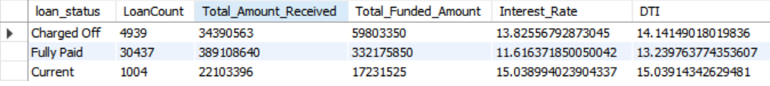

SELECT

loan_status,

SUM(total_payment) AS MTD_Total_Amount_Received,

SUM(loan_amount) AS MTD_Total_Funded_Amount

FROM bankloan.financial_loan

WHERE MONTH(issue_date) = 12

GROUP BY loan_status

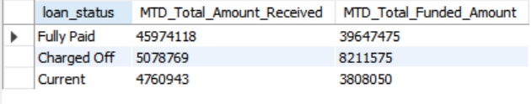

1. **BANK LOAN REPORT | OVERVIEW**

**MONTH:**

SELECT

MONTH(issue_date) AS Month_Number,

MONTHNAME(issue_date) AS Month_name,

COUNT(id) AS Total_Loan_Applications,

SUM(loan_amount) AS Total_Funded_Amount,

SUM(total_payment) AS Total_Amount_Received

FROM bankloan.financial_loan

GROUP BY MONTH(issue_date), MONTHNAME(issue_date)

ORDER BY MONTH(issue_date)

**STATE:**

SELECT

address_state AS State,

COUNT(id) AS Total_Loan_Applications,

SUM(loan_amount) AS Total_Funded_Amount,

SUM(total_payment) AS Total_Amount_Received

FROM bankloan.financial_loan

GROUP BY address_state

ORDER BY address_state

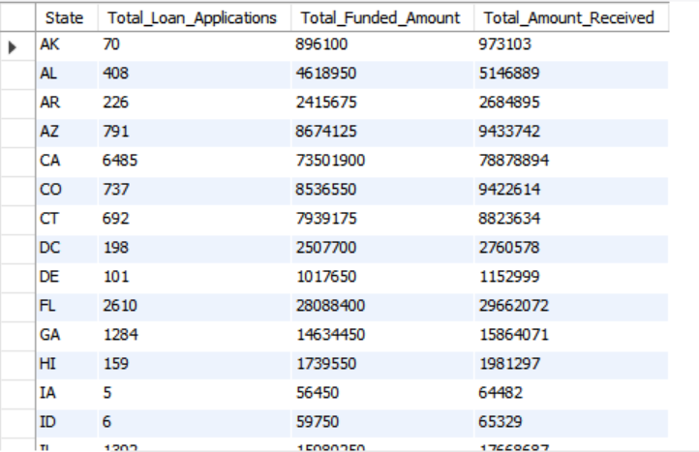

**TERM:**

SELECT

term AS Term,

COUNT(id) AS Total_Loan_Applications,

SUM(loan_amount) AS Total_Funded_Amount,

SUM(total_payment) AS Total_Amount_Received

FROM bankloan.financial_loan

GROUP BY term

ORDER BY term

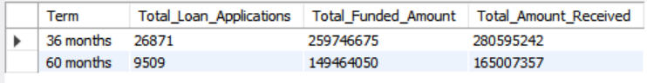

**EMPLOYEE LENGTH:**

SELECT

emp_length AS Employee_Length,

COUNT(id) AS Total_Loan_Applications,

SUM(loan_amount) AS Total_Funded_Amount,

SUM(total_payment) AS Total_Amount_Received

FROM bankloan.financial_loan

GROUP BY emp_length

ORDER BY emp_length

**PURPOSE:**

SELECT

purpose AS PURPOSE,

COUNT(id) AS Total_Loan_Applications,

SUM(loan_amount) AS Total_Funded_Amount,

SUM(total_payment) AS Total_Amount_Received

FROM bankloan.financial_loan

GROUP BY purpose

ORDER BY purpose

**HOME OWNERSHIP:**

SELECT

home_ownership AS Home_Ownership, COUNT(id) AS Total_Loan_Applications,

SUM(loan_amount) AS Total_Funded_Amount,

SUM(total_payment) AS Total_Amount_Received

FROM bankloan.financial_loan

GROUP BY home_ownership

ORDER BY home_ownership

